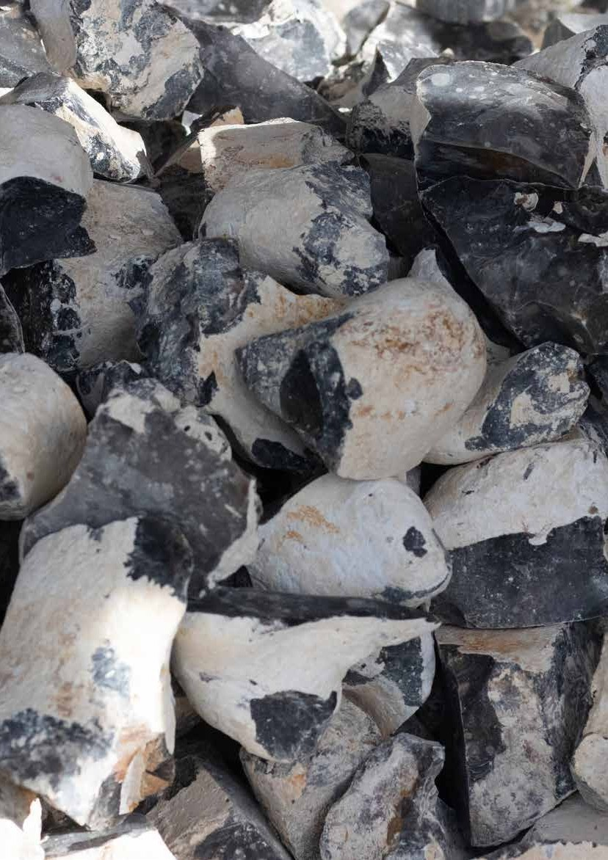
Annual Review
2020 - 2021

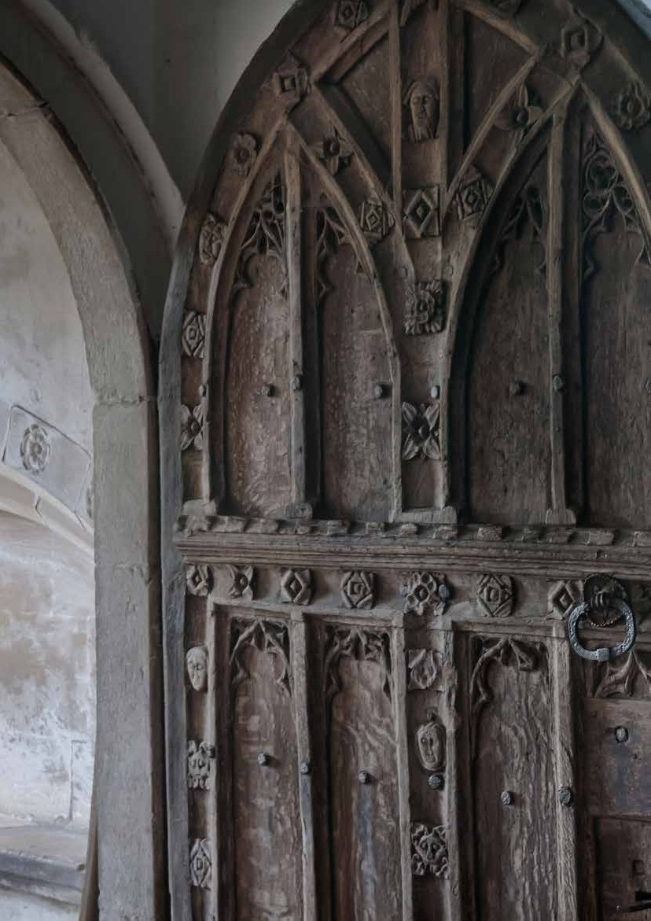

Saving historic churches together

Annual Review 2020-21

Welcome from CCT Interim Chair & CCT Chief Executive 2020 - 2021: A Year Like No Other
Facts and Figures 2020 - 2021 Strategy in Action
Recent Conservation Projects: Heritage Stimulus Fund National Volunteer and Community Day Awards
2-3

4-5

6

7-9

10-11

12

Tributes to Peter Ainsworth and Dawn Whitton 13
Regeneration Update 14
Learning Update 15
Thank You to Our Patrons and Donors 16
Who We Are 17

Copywriters Chana James Jessica Clarke
Liz Parry

Design Jessica Clarke George Reynolds

Cover Image: Flint used at St Mary’s Church in Bungay, Suffolk, during work funded by the Heritage Stimulus Fund (© CCT/George Reynolds) Inside Cover: Medieval door with intricately carved details including flowers and a Green Man at St Mary’s Church, Higham, Kent (© Andy Marshall) Pages 1 - 2 Background: Wallpaintings at All Saints’ Church in Cambridge (© Joseph Casey)
1

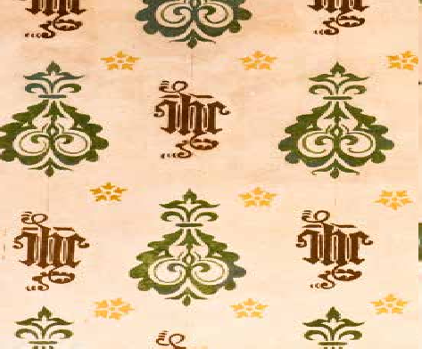
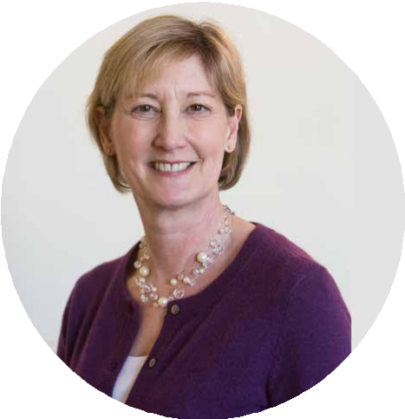


Welcome from Sue Wilkinson
Churches Conservation Trust Interim Chair

Welcome to our Annual Review of 2020/21, which has been an extraordinary year for many reasons. Shortly after the end of the financial year our Chair, Peter Ainsworth, died very suddenly and unexpectedly. This news was a terrible blow, not only to his family, but also to the Churches Conservation Trust and the wider heritage sector. Peter provided sure and steady leadership before and during the COVID pandemic and represented us, in his effective and affable style, to Government, the Church of England and to everyone else who could be persuaded to support us. Peter was a passionate and knowledgeable advocate for historic churches and we consider ourselves very fortunate to have had him as our Chair for five years. He will be missed by us all.
As the financial year began and the pandemic took hold, we acted quickly to protect our volunteers and moved all our staff to work from home. This was managed very well by our Chief Executive and senior team who
were able to limit the impact on our operations. Financially, we faced a significant drop in our income because of cancelled fundraising events and a lack of visitor donations, so we worked hard to curtail all non-essential expenditure. However, thanks to a lot of hard work by our staff and the vital and timely support of DCMS,
the National Lottery Heritage Fund and Historic England, we managed to invest around £1.6m in essential repairs to our buildings, also helping to support the livelihoods of craftspeople and the companies that deliver conservation work.
Our major projects at Sunderland and Worcester, generously supported by NLHF funding, have been significantly delayed over the course of the year and we were hoping to have had them completed, but this will now happen in 2021–22. We are excited at the benefits that these significant cultural assets will offer the communities surrounding them once they open.
I am grateful to all those who have continued to support us and to the large number of people who have joined our membership scheme on the back of our successful Thursday Lunchtime Lecture series. Although our churches stayed open as much as possible, we really missed our local communities who use and love the church buildings in our collection. Bringing people together online, from across the world, to hear erudite lectures on all aspects of church history and heritage was an unexpected highlight. Our online lectures are a lasting legacy of this extraordinary year and we now have a programme booked up into 2022.
The Board is pleased and relieved to report that we have ended this year in a much better financial position than we had thought possible and we are grateful for the ongoing support of DCMS and the Church Commissioners. Peter Aiers has successfully led the charity through its most difficult year in living memory, with much hard work from our excellent senior management team and staff.
There will be continuing challenges in 2022 but we look forward to this next year when we can welcome visitors and communities into our precious collection of historic church buildings across the country.
The Board always gives grateful thanks for our invaluable staff, volunteers and supporters but this has never been more heartfelt. Thank you to everyone.

2

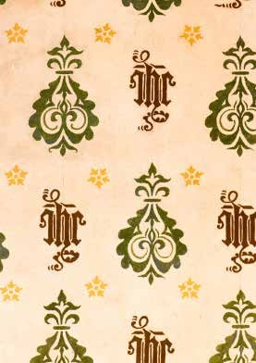
3


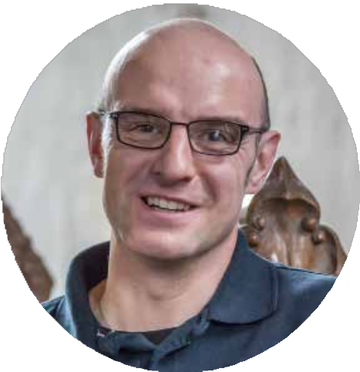
Welcome from Peter Aiers
Churches Conservation Trust Chief Executive

This annual review represents a most extraordinary year in the long life of the Churches Conservation Trust. This was the year that we faced, along with the rest of the world, a global pandemic, as well as the loss of two of our valued colleagues, Peter Ainsworth, Chair, and Dawn Whitton, Conservation Projects Manager. We mourn their loss as both had given CCT their talent and skills over a number of years and we will miss them greatly.
I would like to thank our staff who responded to the circumstances of the year with great resolve and with a drive to ensure that CCT was in the best position it could be despite the circumstances we found ourselves in. The team transitioned to working from home quickly and ensured that our churches were closed, then opened again, and that we found ways to stay in touch with all those communities who live around church buildings in the CCT collection. There was much fundraising to do to help to plug the gaps when events and visitors could not be at our church buildings. Our major projects at Sunderland and Worcester needed to be kept going as well as the continuing development of the Old Black Lion in Northampton and St Peter’s, Sudbury.
We were extremely grateful to DCMS and Historic England for the Heritage Stimulus Funding of £1.6m that we received to repair 26 of our buildings. Not only did this provide a much-needed injection of work for the craftspeople and skilled contractors that we rely on, but it also saw the communities around our church
buildings mobilised to raise the 20% of funding that CCT needed to contribute. Once again this proves that the combination of the national charity and local communities is vital for the future of the precious historic church buildings around the country.
The success of our Thursday online lectures is a lasting legacy of this year. What started as a means of providing our staff with a learning opportunity has grown into a well-supported programme with viewers from across the world. We have been really excited to welcome many more new members off the back of the lectures. We are also very grateful to all those very clever people who have given their time and expertise to give the lectures on all manner of ecclesiastical matters from the naughty bits of historic churches to Oak Apple Day.
CCT is here to empower and support communities to care for their historic places of worship and this partnership has stood this unique collection of buildings in good stead in the most difficult of times. Thank you to all who support their local historic church and all those who support the work of CCT.

A Year Like No Other

July 2020
CCT churches begin to reopen gradually, following a series of COVID secure checks at every church.
CCT Launch its 2020 Annual Appeal: Open Churches, aimed at fundraising to help address a £500,000 loss of income caused by the closure of sites during the COVID-19 crisis.

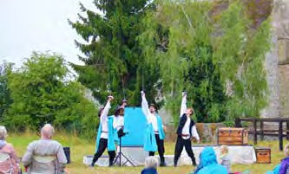
Gizmo the Gargoyle and Ogee the Owl

March 2020

Gizmo and Friends, CCT’s children’s and families’ characters are launched and begin to appear in churches and online.

This Is My Theatre performance of The Three Musketeers at All Saints’ Church , Wordwell, Suffolk (© TIMT)

April 2020
CCT churches close following the announcement of the first National Lockdown in the UK due to COVID-19.
St Peter’s Church in Sudbury, Suffolk, is awarded a £226,000 grant from the New Anglia Local Enterprise Partnership for CCT’s project at the church to repair and regenerate the building as a thriving community hub, alongside a £175,000 grant from Babergh District Council.
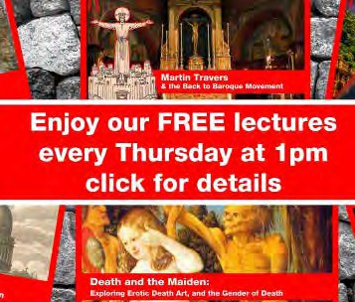
Facebook Banner for CCT’s Thursday Lunchtime Lectures

May 2020
CCT’s Thursday Lunchtime Lectures launch on Facebook, with viewers all over the world tuning in to watch James
II: Celebrating the only Saint to have been canonised by the Church of England given by Fr Charles Card-Reynolds. The lecture would go on to be viewed over 4,600 times on
Facebook and became the first in a series of now more than 60 lectures.

August 2020
Outdoor events return to CCT churches, including perfomances by This Is My Theatre.

ChampingTM, the unique concept of camping in churches, opens for bookings. Providing a COVID Secure and Good To Go staycation at sites across the UK.

September 2020
Heritage Open Days, England’s largest festival of heritage and culture, allows digital events for the first time. CCT registers over 200 online and in-person events.

Jools Holland Presents… A Concert For CCT Churches, a virtual concert presented by composer, singer and television presenter CCT Vice President Jools Holland, takes place on Facebook. The concert included a fantastic mix of wonderful and talented artists who dedicate performances both past and present to their local church.

Jools Holland Presents...A Concert For CCT Churches (© Felix TW)

4

A Year Like No Other

October 2020

The Churches Conservation Trust is announced as one of 445 heritage organisations across the country to receive a financial boost from the Government. This is thanks to a £1.57 bn Culture Recovery Fund for Heritage and the Heritage Stimulus Fund, funded by the Government and administered at arms length by Historic England and the National Lottery Heritage Fund.


CCT recieves £1,354,049 to support projects at 26 churches, funding 80% of funding for each church and requiring 20% of match funding by CCT.
CCT and the Royal School of Church Music (RSCM) partner to create the The Big Christmas Carol Service. The service is led by Chair
of the RSCM, the Very Reverend Dr John Hall and includes readings and contributions from some very special guests including HRH Prince Charles, The Rt Hon Theresa
May MP, Alexander Armstrong and Timothy Bentinck (‘David Archer’). It features a wide variety of music including John

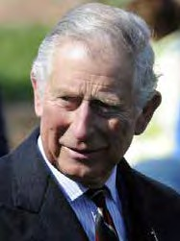
HRH Prince Charles, CCT’s President, introduced The Big Christmas Carol Service (© bibiphoto/Shutterstock)

November 2020
The Reverend Canon Timothy Goode is appointed a member of CCT’s Board of Trustees, by Her Majesty the Queen.
The second National Lockdown due to COVID-19 comes into effect. CCT churches are closed for general visiting, but remain open where possible for independent prayer.

December 2020
CCT’s Candida Lycett Green Memorial Annual Lecture goes virtual with Dr Emma Wells presenting Holy Inappropriate? “Secular” uses of the medieval church live on Facebook.
The lecture explores the suprising ways which ecclesiastical buildings and lands have been used for a multitude of what we may term “secular” activities or, at least, non-specifically devotional purposes including dances, football, bartering, courting and gossiping – not how one would typically describe the everyday happenings of the medieval church.
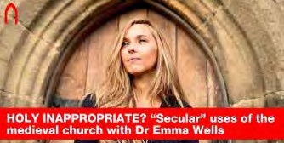
Dr Emma J Wells gave our 2020 Candida Lycett Green Memorial
Annual Lecture in December
5
Rutter conducting one of his own carols. Broadcasted from the beautiful All Saints’ church in the heart of Cambridge, the music includes well-known and loved favourites, as well as approachable new carols.

January 2021
Sarah Robinson, Deputy Chief Executive and Director of Conservation at the Churches Conservation Trust is awarded an OBE in the 2021 New Year Honours List, for services to heritage.
England goes into the third National Lockdown and CCT churches close to general public.

March 2021
CCT holds its first ever virtual Volunteer and Community Event in partnership with the Marsh Charitable Trust. It celebrates the achievements of volunteers and communities from across the country in supporting and caring for their local historic church through the presentation of the Marsh Volunteer of the Year Awards.

Dawn Whitton, Conservation Projects Manager at CCT unexpectedly passes away. (Read our tribute on page 13.)

Project work funded by the Heritage Stimulus Fund is completed at the 26 CCT churches which recieved funding.

April 2021
CCT receives a further grant award of £120,800 from the Culture Recovery Fund, to support a number of activities which need to be undertaken to ensure that our sites are safe and welcoming for visitors and ready to generate vital income to support sustainability.

Peter Ainsworth, CCT’s Chair of Trustees, unexpectedly passes away. (Read our tribute on page 13.)

Key Figures for 2020-2021
Note: some of the usual figures that CCT report on were not collected because of the COVID-19 pandemic and subsequent closure of churches. For example, we did not collect visitor data.








Members: 3,031 (up by 50% on previous year)
We delivered 43 Thursday Lunchtime Lectures and raised just over £28,000 in donations and membership income

Legacies provided £182,000 of unrestricted income
92% of our expenditure was spent on frontline projects

Z
Z
Z

Despite only being able to offer ChampingTM on a severely reduced basis, we still welcomed 931 Champers and generated
£46,870 worth of revenue
Funding from the Heritage Stimulus Fund resulted in a £1.68m major repair programme to 26 of our churches



Heritage Open Days went digital, with CCT listing over 200 events
As part of the Heritage Stimulus Fund project, we worked with more than 70 firms of local heritage contractors and subcontractors, each giving direct and
indirect employment to over 300 tradesmen and craftspeople around the country

6

Strategy In Action
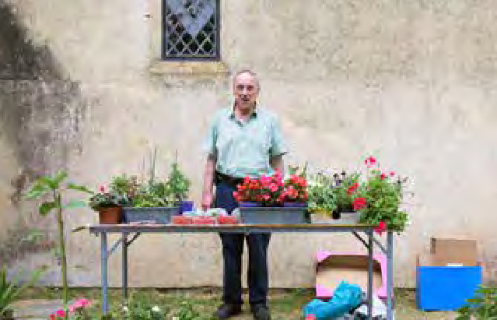
There has been an amazing response from volunteers and communities to the challenges that COVID-19 posed, from the practicalities of closing and then reopening our
churches, to raising awareness of the financial implications of lockdown and the resultant necessary fundraising. They have rallied round to come up with new and creative ways of raising much-needed funds, whilst also supporting their local communities through difficult times.

For example, in Sussex, the Friends of the Church of the Holy Sepulchre in Warminghurst combined plants, cake, and the internet by moving their highly popular May Plant and Cake sale online. The community donated home-baked cakes, preserves, seeds and plants and the resulting stock list was promoted via Facebook, e-newsletters and noticeboards.
Interested punters contacted the Friends to place orders and arrange a socially-distanced drop-off or collection. A small stall and honesty box outside the church catered for the increasing numbers of walkers and cyclists. The sale raised
£420 with a further £130 of donations raised by the generous community through the Friends’ Facebook page.

At St Andrew’s Church, Winterborne Tompson in Dorset, volunteer Rupert Hardy carried on fundraising throughout lockdown. Although the annual church concert was postponed, volunteers emailed attendees from previous concerts, appealing for donations. They also suggested that supporters might consider switching their Amazon accounts to Smile, with CCT as the charity benefiting from 0.5% of transactions.

However it is not just through events and fundraising activities where volunteers and communities can have a positive impact. As most of us ushered in 2021 on the 31st of December sitting in our homes, a shocking event was taking place in one CCT church. All Saints’ Church in East Horndon, Essex, is a Grade II* listed building, which stands in an isolated area near to the town of Brentwood. This usually peaceful place has been part of the local scenery since the 15th century and has seen much in its long life.

It is unlikely, however, that anyone could have predicted what the last few hours of 2020 would bring to the church – as hundreds of revellers descended on All Saints’ on New Year’s Eve for an illegal rave. It is believed that an illegal copy of the keys was used to gain access to the church. Video footage of the event shows hundreds of people at the rave, in breach of the Tier 4 COVID-19 restrictions in place in the area at the time. The event was broken up by Essex Police at around
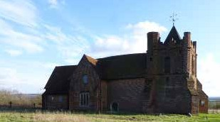
The fundraiser to clean up All Saints’ Church, East Horndon, after it was used for an illegal rave on New Year’s Eve raised over £22,000

Volunteer Robin Williams ran a socially distanced plant sale at St John the Baptist, Strensham, Worcestershire (© Robin Williams)

10pm, with objects being thrown at the police officers as they attempted to disperse the crowd. Three people were arrested on suspicion of drugs and public order offences and the music equipment being used to run the event was seized. For some churches this would unfortunately be the end of the story, but not for All Saints’ thanks to the incredible community around the church and the dedication of a few individuals.

Local volunteer Astrid Gillespie and Revd Canon Paul Hamilton have worked with the local community over the past decade to run a few events every year at the church, bringing people together to experience this special building.

Revd Paul and Astrid visited the church soon after learning about the incident and were appalled to see how the ground outside had been churned up, with litter and bottles everywhere and equipment screwed into the historic walls of the church. The organisers of the rave had even wired a sound system into the church’s fuse box, set up a makeshift lighting rig and pop-up bar area and installed portable toilets
in the churchyard. CCT was quickly informed of the situation, and the Friends worked to organise repair plans.

Soon after returning home from the visit to the church, Astrid set up a Just Giving page to fundraise for the clean-up
and repairs, initially hoping to raise £1,000. In response to supporters’ generosity and the flood of donations coming in, the target was quickly raised to £2,000. In just a few days the fundraiser had met and exceeded this revised target, and over 1,100 people donated to raise over £22,000, which is 1112% of the initial target.

We are indebted to all of the Friends Groups, volunteers and communities across the CCT estate who have worked so hard to fundraise in such challenging circumstances and finding the time and energy to make plans when so much was uncertain. They have also provided a valuable local and safe service for their communities, bringing people together and reinforcing the vital neighbourhood networks that have helped sustain these communities and the special churches at their heart over the centuries.
7

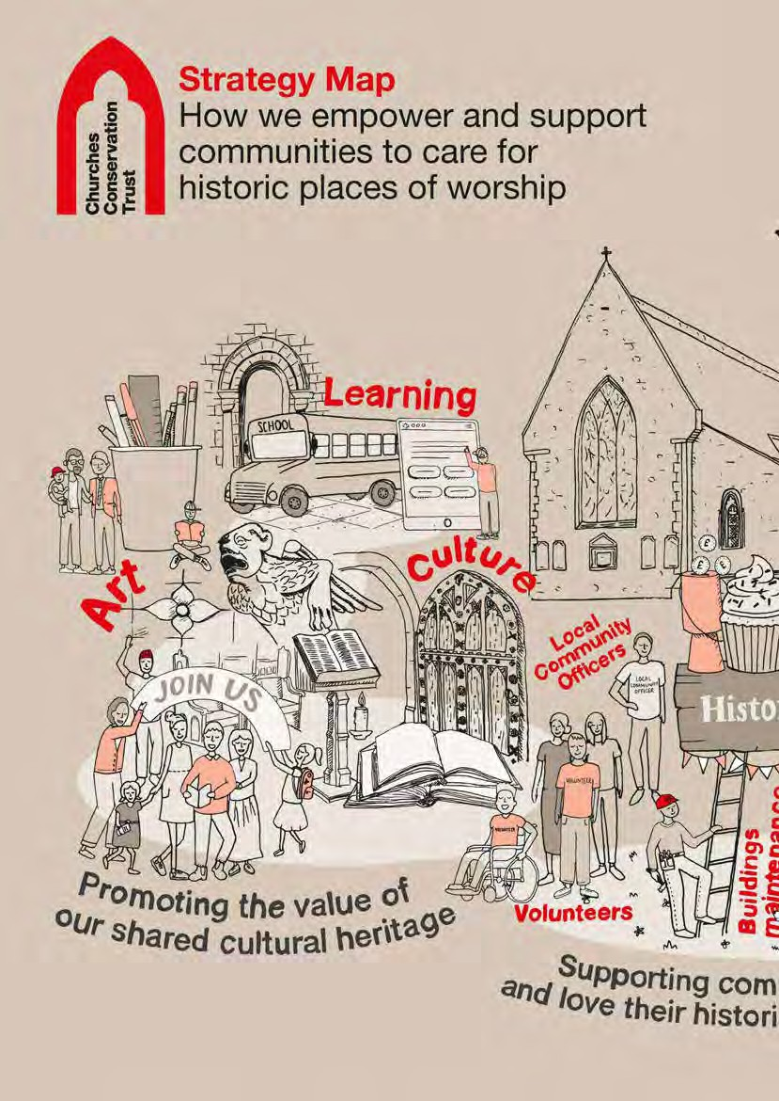

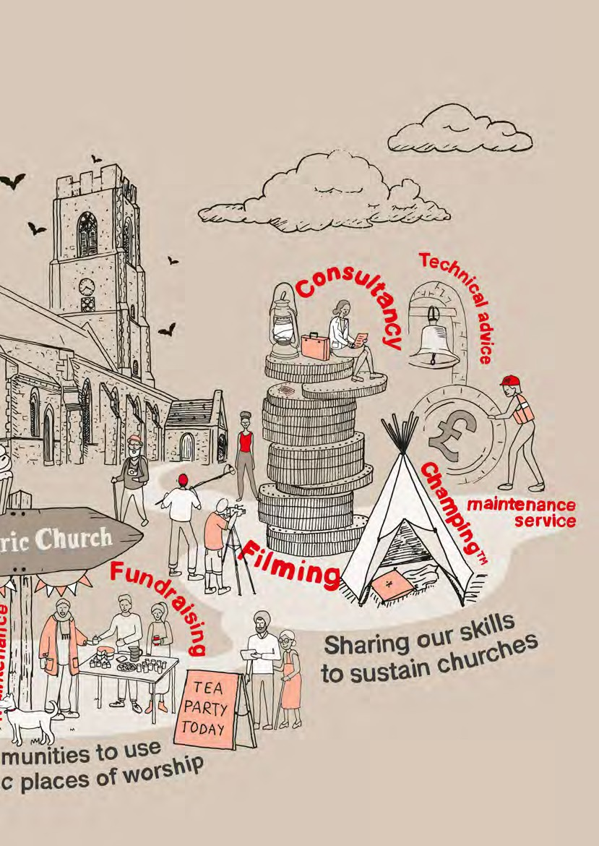

Conservation: Heritage Stimulus Fund
In October 2020, CCT received £1,345,049 as part of the Government’s Culture Recovery Fund which is delivered by the National Lottery Heritage Fund and Historic England, using funds provided by the Department for Digital, Culture, Media & Sport. CCT was one of 445 heritage organisations across the country to have received this funding, with a total of £1.57bn provided by the Government to secure the future of Britain’s museums, galleries, theatres, independent cinemas, heritage sites and music venues.

Applications for funding opened in July 2020 and CCT’s Conservation Team applied to the Programmes of Major Works Grant, part of the Heritage Stimulus Fund, for funding for works urgently needed at a number of churches. This funding stream was most suited to CCT’s needs as the programme of works included urgent and essential repairs due to take place in 2020, but which could not be carried out owing to the restrictions in place to stop the spread of
COVID-19. This included the cancellation of scheduled works and maintenance visits, but also the financial uncertainty caused by the closure of our churches, which meant no
wall-safe donations, community events and fundraisers to help towards these projects.

Not only has this grant allowed CCT to care for historic churches, but it has also helped to fund and protect jobs in the heritage construction sector and underpin the work of specialist heritage professionals and craftspeople – many of whom lost work because of the economic fallout of the pandemic.

While a case for funding could be made for many more than the limited number of churches out of the 356 in our care that were applied for, the team had to carefully select the projects that met all the criteria of the fund. Crucially, each of the projects had to be completed by 31 March 2021, and CCT needed to be in a position to match-fund 20% of the cost of each project, as the grant would only fund 80% of the total cost. In addition, the works needed to be focused on capital repair work such as repairs to roof structures, leadwork renewal, masonry repairs and improvements to rainwater disposal systems.

A total of 26 applications were approved including St Lawrence’s Church in Evesham, Worcestershire, St Mary’s Church in Bungay, Suffolk, and Old Christ Church in Waterloo, Merseyside. These approved projects focused predominantly on roofing and masonry works, including re-roofings for eight churches which have been victims of lead theft. To deliver these projects, CCT has reached out to over 30 consultants and more than 70 firms of local heritage contractors and subcontractors, each giving direct and indirect employment to over 300 tradesmen and craftspeople around the country.
Across the churches, the grant funding has been used to support the employment of a range of different trades including scaffolders, masons, carpenters and traditional glaziers.

The funding has also given us the opportunity to inspire a new generation of heritage and conservation specialists. We know through our experience that offering training opportunities
can inspire the next generation of craftspeople and might also lead to a long-term interest in a historic site. COVID-19 restrictions have posed a few difficulties with running these days as physical events, but we hope to have a series of virtual and digital resources available soon.

We are especially grateful to the Friends groups, individual donors and other grant-making bodies whose support has reduced the call on our limited reserves by contributing towards the final 20% of match-funding required to make these projects happen.
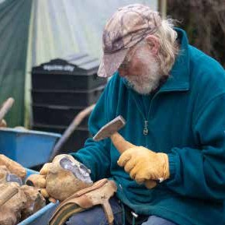
Flint knapping at St Mary’s Church in Bungay, Suffolk, captured as part of the digital programme of technical training.
(© CCT/George Reynolds)

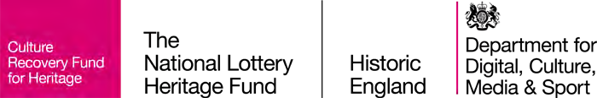

10

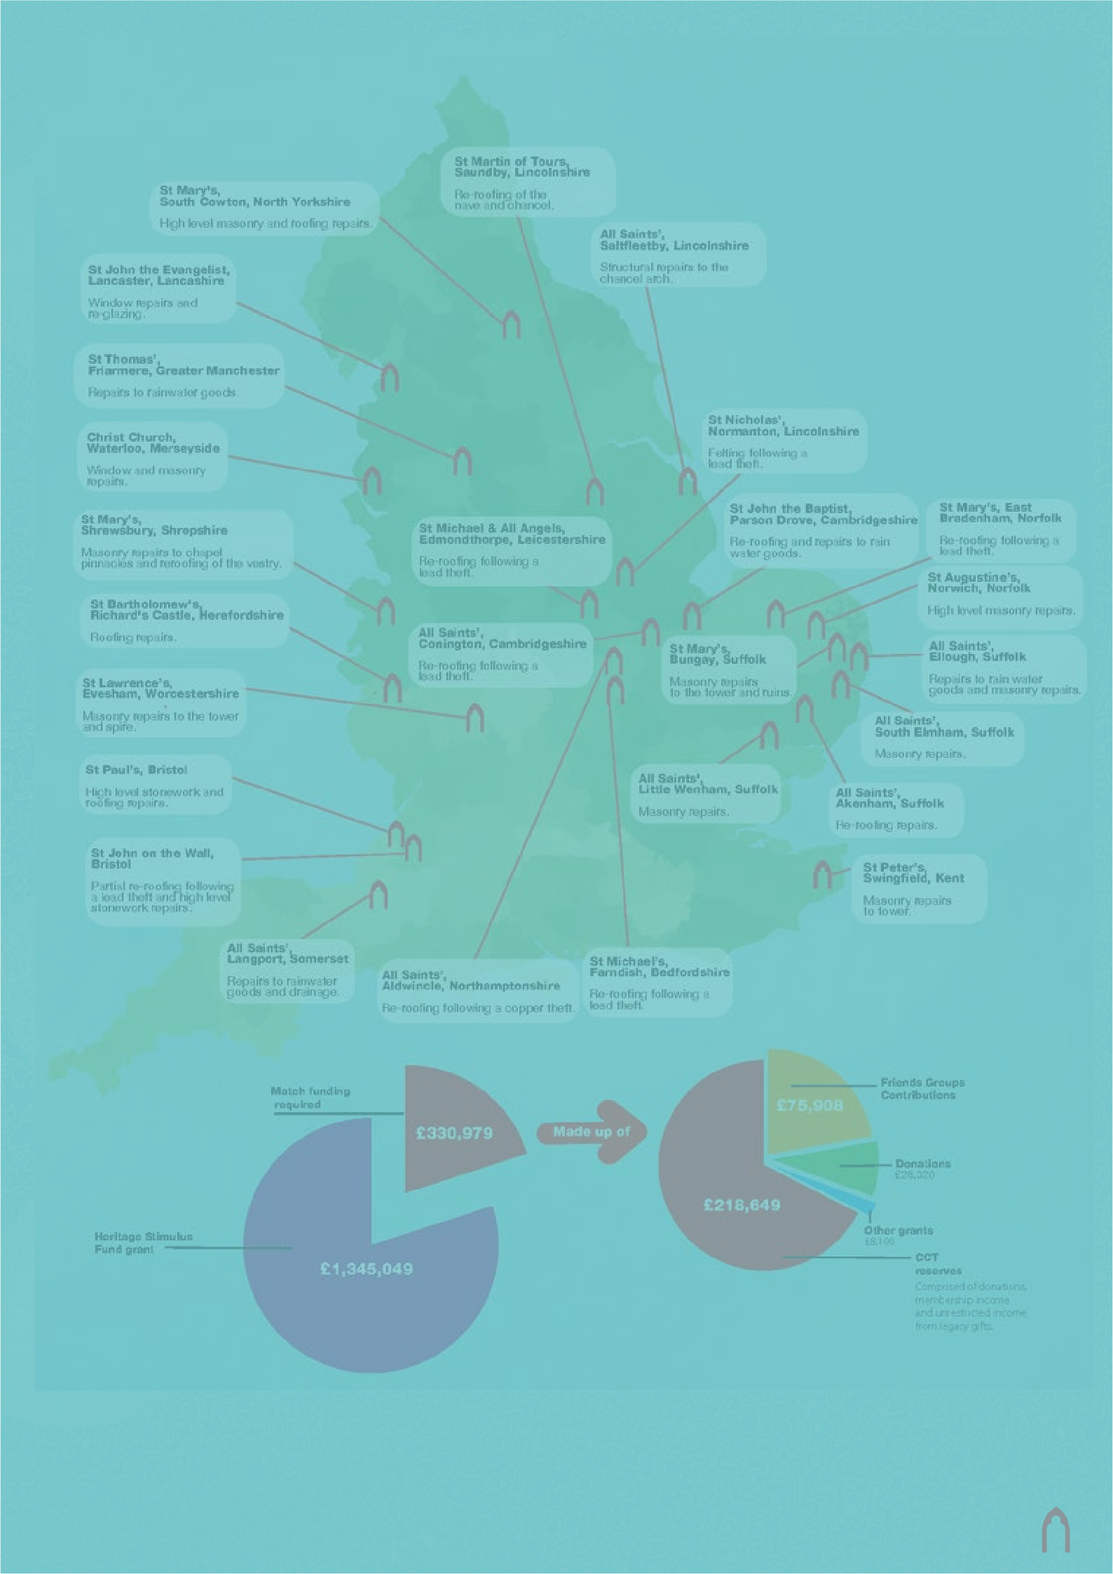
St Martin of Tours, Saundby, Lincolnshire
St Mary's, Re-roofing of the
South Cowton, North Yorkshire nave and chancel.
High level masonry and roofing repairs.
All Saints’,
Saltfleetby, Lincolnshire
St John the Evangelist, Structural repairs to the
Lancaster, Lancashire chancel arch.
Window repairs and re-glazing.

St Thomas’,
Friarmere, Greater Manchester
Repairs to rainwater goods.
St Nicholas’,
Christ Church, Normanton, Lincolnshire
Waterloo, Merseyside Felting following a
Window and masonry lead theft.
repairs.
St John the Baptist, St Mary’s, East
St Mary’s, Parson Drove, Cambridgeshire Bradenham, Norfolk
Shrewsbury, Shropshire St Michael & All Angels, Re-roofing and repairs to rain Re-roofing following a
Edmondthorpe, Leicestershire
Masonry repairs to chapel water goods. lead theft.
pinnacles and reroofing of the vestry. Re-roofing following a
lead theft. St Augustine’s,
Norwich, Norfolk
St Bartholomew's, High level masonry repairs.
Richard's Castle, Herefordshire
Roofing repairs. All Saints’,
Conington, Cambridgeshire St Mary’s, All Saints’,
Re-roofing following a Bungay, Suffolk Ellough, Suffolk
St Lawrence’s, lead theft. Masonry repairs Repairs to rain water
Evesham, Worcestershire to the tower and ruins. goods and masonry repairs.
Masonry repairs to the tower All Saints’,
and spire. South Elmham, Suffolk
Masonry repairs.
St Paul’s, Bristol All Saints',
High level stonework and Little Wenham, Suffolk All Saints’,
roofing repairs. Masonry repairs. Akenham, Suffolk
Re-roofing repairs.
St John on the Wall,
Bristol St Peter’s,
Partial re-roofing following Swingfield, Kent
a lead theft and high level Masonry repairs
stonework repairs. to tower.

All Saints’,
Langport, Somerset St Michael’s,
Repairs to rainwater All Saints’, Farndish, Bedfordshire
goods and drainage. Aldwincle, Northamptonshire Re-roofing following a
Re-roofing following a copper theft. lead theft.

Contains Ordnance Survey data © Crown copyright and database right 2019. Holmes, Ian. (2017). Mean High Water Springs Polygon, [Dataset University of Edinburgh. https://doi.org/10.7488/ds/1969. This dataset was first accessioned in the EDINA ShareGeo Open repository on 2014-11-19 and migrated to Edinburgh DataShare on 2017-02-22. Contains Natural Resources Wales information © Natural Resources Wales and Database Right. All rights Reserved. Contains Ordnance Survey Data.Ordnance Survey Licence number 100019741. Crown Copyright and Database Right. These data were extracted from the GADM database (www.gadm. org), version 2.5, July 2015.

11

Outstanding Contributions
Every year CCT recognises the incredible support and outstanding contributions of the volunteers who help care for our churches at the national volunteer and community day, culminating in the Volunteer of the Year Awards generously supported by the Marsh Charitable Trust. This year, due to the second lockdown preventing an
in-person gathering, the event went virtual for the first time on 4 March.

Achieving Impact Through Innovation
Alexander Clark - Holy Trinity Church, Sunderland, Tyne & Wear

Alex is part of Seventeen Nineteen’s Cabinet of Curiosity team, taking part in fortnightly Zoom meetings to develop ideas for the interpretation of our silver collection. Alex has been extraordinary in these meetings, helping to carve
out space for collaboration and conversation to make sure all members of the team get a chance to share their thoughts. Alex easily combines his passion for history and heritage with a digital acumen, to reach local Sunderland communities and make sure their voices are heard.

William King - St Mary the Virgin, Shrewsbury, and St Andrew’s, Wroxeter, Shropshire

William joined the volunteering team in Shrewsbury three years ago as a Visitor Welcome Steward to assist with meeting and greeting visitors. William’s approach has extended beyond St Mary’s to include other CCT hurches in the Shropshire area, including St Andrew’s Church in Wroxeter, where he encouraged visitors to walk down to the church to view the Roman Ruins while volunteering with Historic England at their site of Viriconium.
South-East Volunteer of the Year
Robert Cairns - All Saints’, Wordwell, Suffolk

CCT is incredibly fortunate to have benefitted from Bob’s generous support of All Saints’ for over 20 years. He is our only key holder and volunteer at this church, so he undertakes its daily opening and regular cleaning alone.
Despite the lockdown and subsequent restrictions in 2020, Bob’s support did not waver and he continued to open the church where possible, despite shielding.

Dr Natalie Gibson - St Mary the Virgin, Wiggenhall, Norfolk

St Mary’s contains some items of great historical significance, most notably a pre-Reformation lectern, so it has in the past been the unfortunate target of heritage crime. Natalie keeps a close eye on the church, opening and closing it at a moment’s notice where required, often using her own initiative, to keep this important site safe. Despite being a keyworker (Natalie is a local GP), she has still found time to check the church and provide us with regular updates.
West Volunteer of the Year
Pamela Law - St Michael & All Angels, Princetown, Devon

Despite no longer living in Princetown, Pam has been a massive support during 2020, helping with the closure of the church after the first lockdown was announced. Pam regularly empties the donation box, counts visitor numbers, puts fresh flowers in the church, keeps the place looking spick and span, and completes the biannual site inspection form. She also fundraises with the Christmas raffle, helps organise the annual Carol Service, and assists with arrangements for services and visitors.

Fundraising Volunteer of the Year
Digital Volunteer of the Year
Maria Watson - Hampshire Area Volunteer

Maria created a brilliant trail linking four of our Hampshire churches to the gin industry of the area. The trail featured information gleaned from local volunteers about each church and their connection to gin! Writing her own script, presenting the virtual tour and coordinating the video editing of the final product, Maria was resourceful and dedicated.
Friends of All Saints’, East Horndon, Essex

The Friends of All Saints’, East Horndon, have helped to care for this beautiful church for many years. Their nomination was inspired by events that took place at All
Saints’ on New Year’s Eve this year, where the actions of the Friends turned a shocking illegal rave at the church into an inspiring fundraising story.
Volunteer Team of the Year
Volunteer Team at Holy Trinity, Privett, Hampshire

The team at Privett have always been a strong and proactive team and this year they have not allowed COVID-19 to hinder their efforts. Over the past year they have worked with the PCC on a project to clear the
churchyard, contributed to a Virtual Gin Trail of Hampshire as part of Heritage Open Days and hosted their first virtual Christmas Carol Service.
North Volunteer of the Year
Janet Hall & John Gill - St John’s, Stanwick, North Yorkshire

As members of the local community, Janet and John have been supporting St John’s for longer than it’s been in the care of CCT. As for many, 2020 has presented them with some real difficulties, but they have dug deep and carried on despite the restrictions and limitations. They helped out with a deep clean of the church to prepare it for a COVID- secure wedding and had a great Heritage Open Days festival, with Janet providing some popular guided tours as well as producing a series of audio tours about the church and the local area.



12

In Memoriam

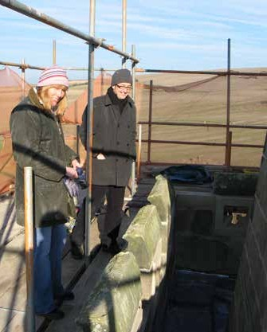
Dawn Whitton and CCT’s former CEO Crispin Truman examining tower stone at St Peter’s Church, Wintringham,
North Yorkshire in 2007

Remembering Peter Ainsworth
Peter Ainsworth, CCT’s Chair of Trustees, passed away unexpectedly on 6 April, at the age of 64. Peter gave over 30 years of commitment to public life and has made a significant contribution to the heritage sector. His involvement in heritage dates back to 1995, when he was appointed Parliamentary Private Secretary to the Secretary of State for National Heritage. He was a member of the DCMS Select Committee in 2009-10. Peter was appointed Chairman of the Churches Conservation Trust in July 2016 and was made Chair of the Heritage Alliance in 2018.

Peter’s parliamentary career also saw him serve as Shadow Secretary of State for Culture and Shadow Secretary of State for Environment, Food and Rural Affairs. He was Member of Parliament for East Surrey for 18 years until 2010. He was UK Chair of the Big Lottery Fund (now the National Lottery Community Fund) from 2011 to 2019 and was a board member of the Environment Agency. He was also previously Chairman of Plantlife International and the Elgar Foundation.

A former investment banker, Peter was a founding partner of the sustainability consultancy the Robertsbridge Group. He was also a Patron of the College of St Barnabas, a residential community of retired Anglican clergy in Lingfield, Surrey.

Oliver Dowden, Former Secretary of State for DCMS said, ‘It is with deep sadness that I learned of Peter’s death. He was unfailingly kind, charming and a committed public servant, which he demonstrated most recently as a passionate Chair of the Churches Conservation Trust and the Heritage Alliance. We will miss him greatly, and my thoughts are with his family at this difficult time.’

Remembering Dawn Whitton
Dawn Whitton, Conservation Projects Manager at CCT, passed away suddenly on 10 March, aged 56 years. Dawn was a much-loved daughter, sister, aunt and much-adored wife and partner of Jasper for 31 years.

Dawn grew up in Durham and studied at Newcastle, Leicester and Colchester, obtaining an undergraduate degree in Fine Art, a Postgraduate Diploma in Library Conservation and an MA in Architectural Building Conservation. Dawn worked in historic building conservation for Essex County Council and North Yorkshire County Council, where she also worked as Consultant Conservation Officer for the North York Moors National Park Authority.

Dawn joined CCT in 2002. She loved the challenge of taking dusty and neglected buildings and turning them into beautiful churches. Dawn’s memory will be with us in every stone carved, every tile laid and every pew repaired under her exacting gaze during her two decades at CCT.

Dawn leaves a significant conservation legacy from her work on CCT buildings in the North Region and will be sorely missed. We have lost a great champion of conservation.

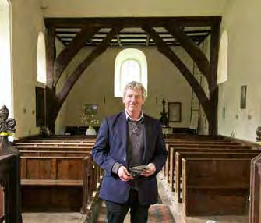
Peter Ainsworth at St Andrew’s Church, Willingale Spain, Essex

The Churches Conservation Trust is really grateful for Peter’s five years as Chair, seeing the organisation through a change of Chief Executive, the implementation of a new strategy and the pandemic. At the Heritage Alliance, Peter chaired the organisation through the pandemic, which affected many
of its members. They are extremely grateful for the way in which he both supported the Alliance’s growth and tirelessly championed these organisations – numbering more than 150.

Our thoughts are with Peter’s wife, children, grandchild and family at this time, who are kindly asking for donations in memory of Peter to be made to the Churches Conservation Trust. Donations can be made at visitchurches.org.uk/donateinmemoryofPeterAinsworth

13

Regeneration Update

Seventeen Nineteen, Sunderland, Tyne & Wear

Work on site was impacted by both COVID-19 and Brexit, and programmed works due for completion at the end of August 2020 will now be complete by autumn 2021. Despite these setbacks there are some tremendous successes.

Two local young people have each completed a heritage construction apprenticeship (joinery and general maintenance operative). Tyler has gained full-time employment with Historic Property Restoration (HPR) and will go on to work on the prestigious Alnwick Castle. HPR are continuing to invest in his future and he has been accepted on to the stonemasonry course in York. He has also been shortlisted for apprentice
of the year (North East). Luke, who has been on a work experience placement with HPR, has also gained a full-time apprenticeship with the company, with several learners from the local college engaged in learning outside of the classroom.

During the pandemic, site staff have had to operate in a new way, adapting to using digital technology and a hybrid digital delivery model to engage with audiences. We have hosted over 40 live Digital Picnics engaging over 14,000 people. The project has recruited 35 new volunteers, five of whom have gained employment in the heritage and cultural sector.
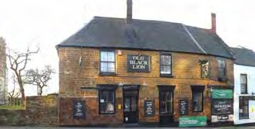
Old Black Lion Pub, Northampton
(© CCT/Rebecca Tate)
Sound & Art at St Swithun’s, Worcester

At the beginning of 2020, conservation work at St Swithun’s was progressing at a pace, when, like the rest of the country, the effects of the pandemic struck. As the restrictions of the first lockdown were imposed, all construction work on the Grade I listed church ceased and the site was closed.

As restrictions eased, contractors came back to the church to continue their work, but global shortages of materials, social distancing and COVID control measures all contributed to further delaying the construction programme. Through the programme of conservation and adaptation, Sound & Art at St Swithun’s will become a space that uses sound and art to engage, enthuse and inspire audiences. It is planned to fully launch in February 2022.
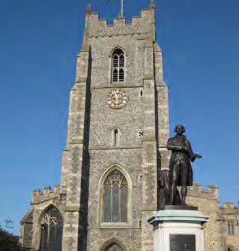
St Peter’s Church, Sudbury, Suffolk

The Old Black Lion Project, Northampton

The Churches Conservation Trust is leading an innovative project at St Peter’s Church and its neighbour, the Old Black Lion public house in Northampton. The Old Black Lion closed in 2018 and has been deteriorating since.

The pub is owned by West Northamptonshire Council but will be leased to CCT as part of a project to regenerate it as a community-based public house, run by a hospitality operator selected by the Trust. A portion of the profits from the enterprise will go towards repairing and conserving St
Peter’s Church, which the Trust has looked after since 1998. The majority of the project funding is from the National Lottery Heritage Fund, which has awarded CCT an Enterprise Grant of £1.8m.

The wider regeneration goals of the project – which include new landscaping in the churchyard, biodiversity initiatives, community activities, and creating new jobs in the pub
– have also attracted funding from HM Treasury, West Northamptonshire Council and the Architectural Heritage Fund.

14
St Peter’s, Sudbury

Since April 2020, significant progress has been made on the regeneration project at St Peter’s, Sudbury. The project’s final funding application was made in May 2020 to the National Lottery Heritage Fund (NLHF). The NLHF reviewed the bid over the summer months and confirmed that our bid was successful in the following September. Permission to start was granted shortly after, and the technical design work commenced immediately.

Over the following six months, the project team refined the architectural and engineering designs, including a number of construction impact and management plans. The procurement process also began in this period, with expressions of interest released to several appropriate contractors.

During this period, major advancements were also made among the local community. Various groups and organisations have been brought on board, with many expressing an interest in being involved with St Peter’s once the building reopens.

Learning Update
Learning in lockdown

In any normal year, the Learning and Participation Team would have been at its busiest from April through to mid-July. CCT’s Heritage Learning Team would spend at least half of their time preparing and delivering curriculum-based learning for school pupils of all ages. Dusty churches would be transformed
into lively classrooms and, braced by fresh air and a new environment, school pupils could discover a wealth of new knowledge. Subjects would range from how to measure distance and air pressure, to finding out about a young man not much older than them who, 80 years ago, went off to war and never returned.

But, of course, 2020 was not ‘any normal year’. As church doors were forced to close, it soon became obvious that digital access would be the only way for people to engage with these spaces. The team created a range of resources for people of different ages and abilities – not just school learners – to help people stay mentally active.

The Resources for Life in Lockdown included family activity sheets demonstrating, for example, how to make a ‘nosegay’ (better known as a posy), word searches and brainteasers on church features and architectural terms, and creative tasks based on stained-glass windows. The existing virtual tours, hosted on Google Arts & Culture, became incredibly useful tools for delivering remote learning: pupils were able to explore some of our churches via the internet and accompanying written resources.

As churches started to reopen to the public, the team were able to add to the collection of digital exhibitions, virtual tours and audio guides and make them more easily accessible via the website. There were already plans to create more digital resources, but we didn’t understand at the start of the year just how useful this content would prove to be. It has helped to keep people connected and engaged in our work over a period which might usually see about 1.8m visitors cross the thresholds of our 356-strong collection.

Social media also proved to be a vital tool when the pandemic hit, as people took to their devices from lockdown at home
to see what was happening beyond their front door and connect with others. We were able to reach out to new and existing supporters/followers of our cause online. In May 2020 CCT’s first Lunchtime Lecture was broadcast live to
hundreds of followers via our facebook page: Facebook.com/ ChurchesConservationTrust and later uploaded to YouTube for anyone to watch at any time. This first lecture – ‘Celebrating the only Saint to have been canonised by the Church of England’ – was given by Fr Charles Card-Reynolds, Chaplain to the Society of King Charles the Martyr and Parish Priest at St Bartholomew’s on Stamford Hill.

At the time the lecture was broadcast, we knew it was likely to pique new interest in the fascinating stories surrounding historic parish churches. We didn’t imagine, though, that over a year on hundreds of people would spend their Thursday lunchtimes with us every week. The series has been put together by CCT’s Communications Team, who can usually be found in the comments section of every lecture. Speakers

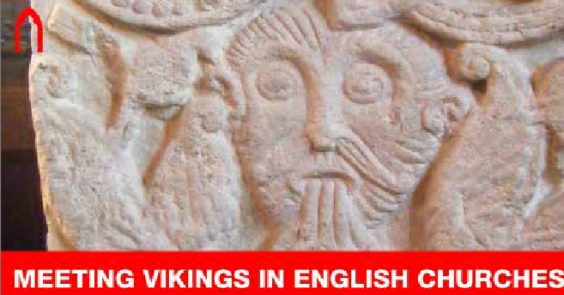
In March Dr Eleanor Parker from Brasenose College, Oxford, explored some of the different ways visitors might come across Viking history in
English medieval churches.

have included a range of experts who represent prestigious academic institutions and the Church, as well as television broadcasters. These have included: Dr Emma Wells, Dr Christina Welch, Loyd Grossman CBE, writer, broadcaster and former Chair of CCT, to name just a few.

Thanks to the expertise of the 50-plus wonderful speakers who have given time and brought such enthusiasm to our lecture series CCT has raised over £30,000 to help save historic church buildings and has welcomed more than 500 new members to our charity. Not only has this new venture raised money for the Trust during these trying times, but it has also allowed us to reach a large new audience who are now aware of our unparalleled collection of historic churches and are engaged in the cause of saving this vital heritage for future generations.

We are grateful to everyone who joins our lectures – from first-time viewers to weekly regulars – and to those using our
online resources and enjoying our virtual exhibitions. We have begun nurturing a committed and enriching online community which helps CCT to care for historic churches.
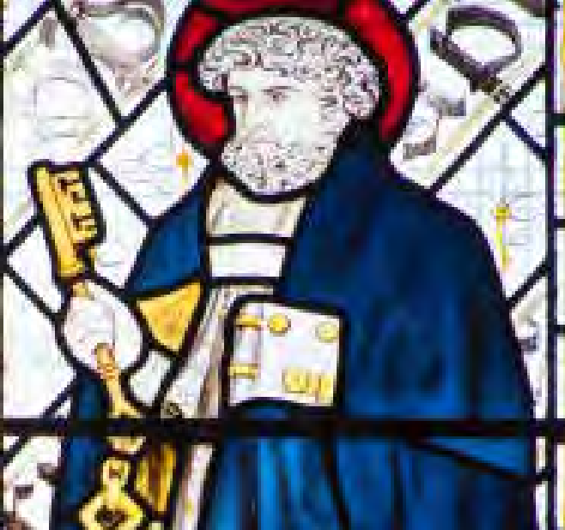
The Learning and Participation Team also put together creative activities based on stained-glass windows, using examples from All
Saints’ Church, Cambridge (© Andy Marshall)

15

Thank you to our Sponsors and Donors

The Trust wishes to record its thanks for the continuing help and support it receives which enables it to do its work across its 356 churches. The list below notes the Trust’s sponsors (who provide its Statutory Grant), Key Funders, Trusts, Foundations, Friends of Churches, other organisations and individuals that in the year gave generously to the Trust. We are also grateful to those who would like their support to remain anonymous.

The Trust’s Key Sponsors
The Department for Digital, Culture, Media and Sport The Church Commissioners
The Department for Education
The National Lottery Heritage Fund The Culture Recovery Fund Historic England

Chancel Club
Ralph & Elizabeth Aldwinckle Michael Bartlett
Stephen Chater Adrian Clark Tim Clarke
Stephen Dawson & Tom Peers William Donaldson
Judith Donovan CBE



James Gilpin Tim Harris
Rupert Lycett Green Professor Vincent Porter Michael Rimmer Professor Andrew Spicer Margaret Thornton

Bulmer-Thomas Circle

Peter Aiers
Professor Victor Bulmer-Thomas CMG, OBE Jonathan Clowes
The Revd Richard Coles Lord Patrick Cormack Alison Dumbell
John Goodall
Edward Harley OBE, DL Philippa Hudson
Chris Kenny Mark Kirby
Christopher Knight
Peter & Pamela Mansfield John Newman FSA Alison Oliphant
Colin & Brenda Soden Michael Walker Miranda Wilson

Donors

Dr John and Mrs Lucia Annear Ned and Neva Asplundh
John and Audrey Barkshire Simon Barrett
William Dove
Mark Nicholas Mason Ellis Dr Norma O’Flynn Michael Fowle CBE, FCA Peter Gent
Professor Richard Jenkyns
Ian Lennox
Robert McCracken QC Colin McCorquodale Ronald Mitchell
John Norman John Osborn CBE
Bob and Claire Stacey Lesley Thomson
Simon and Noni de Zoete

Corporate Partners
E-Bound AVX Ltd Ecclesiastical
Starck Uberoi Solicitors Ltd

16

Trusts, Foundations and Organisations

Allchurches Trust Architectural Heritage Fund
Babergh & Mid Suffolk District Council Bayfield Charitable Trust
Bolton Council
Culture Recovery Fund
Divisional Fund of Bob Banks – Evesham Councillor Divisional Fund of John Smith – Evesham Councillor Fitzwilliam Wentworth Amenity Trust
Friends of All Saints’, East Horndon Friends of Botolph’s Church
Friends of Old Christ Church, Waterloo Friends of St Mary’s Church, Bungay Friends of St Mary’s, Stainburn Friends of St Peter & St Paul, Albury Harrison’s Charity
J Paul Getty Jnr Charitable Trust
Rupert and Elizabeth Nabarro Charitable Trust
Shrewsbury Town Council
Sir John Priestman Charity Trust
Suffolk County Councillor David Ritchie from his Locality Budget Suffolk County Councillor John Field from his Locality Budget The Christmas Carol and Summer Evensong congregations of St Peter ad Vincula, Colemore
The Fairfield Charitable Trust The Geoffrey Watling Charity The Ian Askew Charitable Trust
The Loppylugs & Barbara Morrison Charitable Trust The Osberton Trust
The Parish of Christ The King, Paola, Malta Giuseppe Piero Mastrovalerio, Sicily, Italy The Prynce’s Holme Lacy Charity
The Spiller Trust
The WGFJM Charitable Trust Tom Hall Charitable Trust Worcestershire County Council

Pledged gifts in wills
Gifts in wills play an important and much-valued part in supporting the work of the Trust. We would like to thank the following named donors and those who wish to remain anonymous for pledging a gift for the Trust in their wills:

Christopher Anderson Nigel Benford
Darrell Buttery Richard Digby Day

Who We Are
David Flemington Paul Mollard Robert Perrin
Howard & John Pescott

The Churches Conservation Trust is the national charity protecting historic churches at risk. Since 1969, we have played a unique role in national life. Without our work, 356 historic churches might have disappeared entirely and, with them irreplaceable architecture, art and archaeology spanning over 1,000 years of history.

President
His Royal Highness the Prince of Wales

Vice Presidents and Patrons
Baroness Kay Andrews OBE
Lord Brooke of Sutton Mandeville CH, PC Debbie Dance OBE, MSc, FRICS, IHBC, RSA The Rt Hon. the Lord Field of Birkenhead, DL Dame Liz Forgan DBE
Dr Loyd Grossman CBE, FSA Jools Holland OBE, DL
Dr Bettany Hughes OBE, FSA Dr Janet Townsend-Stojic

Our Trustees
Peter Ainsworth – Chair (to April 2021)
Sue Wilkinson - Interim Chair (from April 2021) William Donaldson
The Revd Canon Timothy Goode (from December 2020) Edward Harley OBE
Sir Simon Jenkins FSA, FRSL
Beth McHattie (to September 2020) Carol Pyrah
Liz Peace CBE

Chair of the Conservation Committee
Carol Pyrah

Chair of the Finance, Audit and Resources Committee
Liz Peace CBE

17


 TheCCT
 ChurchesConservationTrust  ChurchesConservationTrust
 The Churches Conservation Trust

TheChurchesConservationTrust

visitchurches.org.uk


Churches Conservation Trust Society Building, 8 All Saints Street London, N1 9RL
Registered Charity No. 258612

